GCSE Geography Fieldwork

Resources to use
You should make full use of the following resources when you are completing these sheets:
- The background theory notes on counterurbanisation
- The notes on questionnaire design and implementation.

There is only one single piece of coursework for GCSE Geography. However, it is worth 20% of your GCSE, so it is very important to produce your best work at all times. These sheets you are about to fill in are the planning component of your coursework. They are worth 10% of the overall coursework and should be stored carefully, as you will have to include them in your project when you hand it in.

The title of the course work is:

This is the question we will be seeking to answer by conducting the coursework. We will examine a range of pieces of evidence to determine whether or not Moira has experienced counterurbanisation.

1. Background theory
Use your background theory sheets to answer these next questions.
What is counterurbanisation? __________________________________________________ __________________________________________________________________________ __________________________________________________________________________

Why does it occur?
__________________________________________________________________________
__________________________________________________________________________
__________________________________________________________________________
__________________________________________________________________________
__________________________________________________________________________
__________________________________________________________________________
__________________________________________________________________________
__________________________________________________________________________

Why is Moira such a popular place for counterurbanisation?
Add annotation to this map to explain why Moira is so popular for counterurbanisation. Discuss the full range of the pull factors we covered in your background theory sheets.

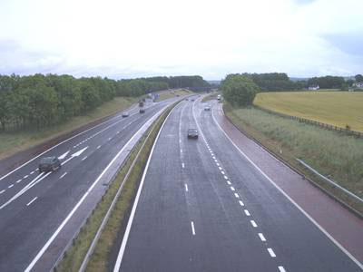
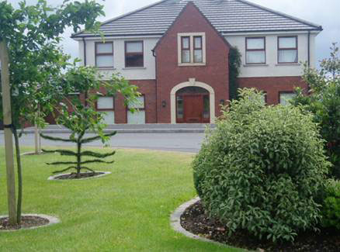
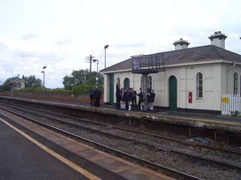
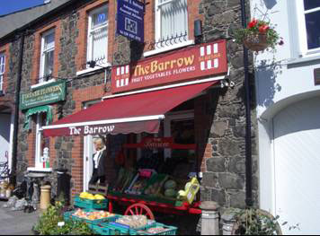
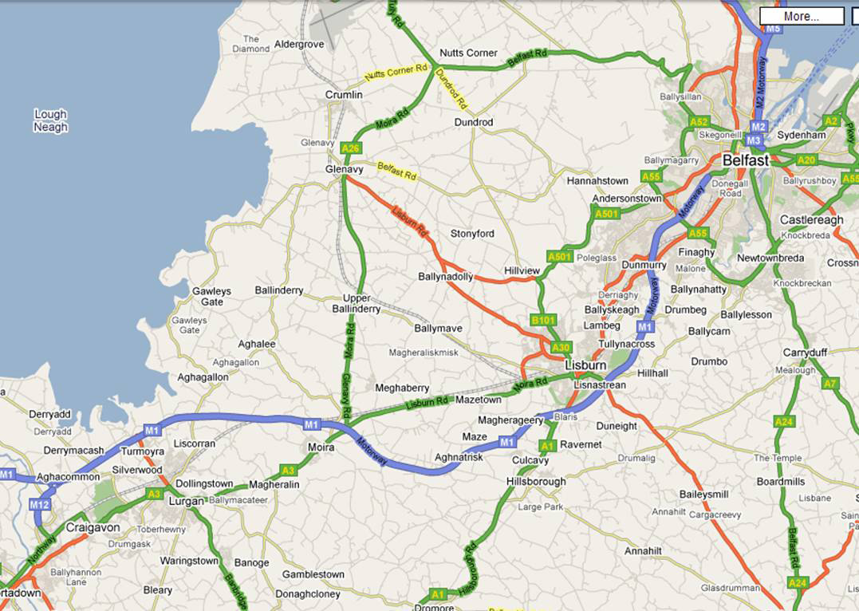
2. Brainstorming
If we think Moira has experienced counterurbanisation, we would expect to be able to observe things about the village that would be evidence to point to this fact. Use your CSI ppt to help you produce a spider diagram outlining a wide range of pieces of evidence we could look out for in our fieldwork.

What is the evidence we could gather to help us answer our aim?
3. Objectives
To collect data on all the evidence we could gather would take too much time and be beyond the scope of a GCSE project. We will therefore focus our investigation on the following aspects of counterurbanisation with the help of some objectives (see inset box).
An objective is a short, clear statement of what you intend to do. For example, your own personal objective for this coursework may be ‘To produce my best work in order to earn the highest mark I can.’

Objectives always start with a verb eg to investigate, to examine, to explore etc.

The main aspects of counterurbanisation we will be studying are:
- The change in the morphology of Moira over time.
- Where the new residents of Moira have moved from.
- The differences in the characterisitics of the old and new residents of Moira in terms of:
  - socio-economic group;
  - age structure.

Draw up three objectives covering the above aspects (use the standard wording for objectives).

(1) To ______________________________________________________________
___________________________________________________________________
(2) To ______________________________________________________________
___________________________________________________________________
(3) To ______________________________________________________________
___________________________________________________________________

4. Data Collection methodologies
A. Changing morphology
The data for objective 1 will be collected via old maps obtained from the library.
B. Environmental survey design
To help you observe the environment of Moira as closely as possible, we will carry out an environmental survey in three locations. What kinds of things would it be good to look out for in these locations?
- Housing Areas
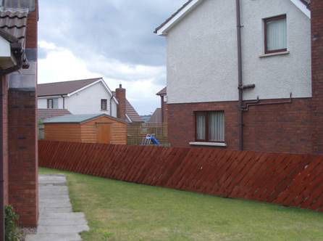
- Main Street
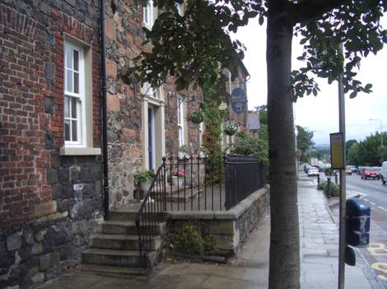
- Railway station

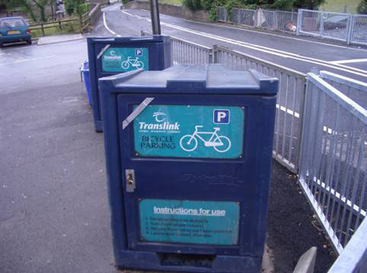
C. Questionnaire design and initial draft
The data for objectives ______________ will be collected using a questionnaire.

- Question wording: avoid the overindulgence in unnecessarily verbose and overly-complex geographical terminologies when formulating your questions! ie____________________________
eg specific terms such as ___________________________________________________

- Question type
  - Open ie
  - Closed ie
Consider objectives 2 and 3. Should open or closed questions be used and why?

- Order of questions – which question should go last and why?

- Politeness – be polite!
  - At the start:

  - At the end
Bearing the above in mind, draft out a questionnaire that we could use to help us to fulfil the objectives. Include a suitable mix of open and closed questions and add annotation around it to justify and explain your design.

5. Safety issues
When conducting any piece of fieldwork outside of the classroom, it is vital that safety issues be considered before conducting the field trip. We can do so under the following headings:
- Risk assessment
- Precautions
- Procedures
We will consider each of these in turn for our field trip to Moira, using the following table to help us.

Risk Assessment | Precautions | Procedures

